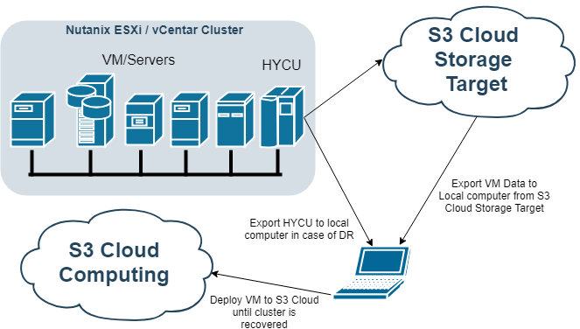
DR Recovery Scenario for Amazon cloud
Prerequisites:
- Working Windows Physical Machine
- vmPlayer available for download on https://www.vmware.com/products/workstation-player/workstation-player-evaluation.html
- Installed and configured QEMU package for converting Virtual HDD files, Download QEMU From https://www.qemu.org/
- Backup of HYCU controller (exported Virtual HDD files)
NOTE: use CTRL+ left mouse click on video links to open video
IMPORTANT: Watch for uppercase and lowercase letters in command

PREREQUISITE STEP 1 (Get and Install QEMU) video file
- Get QEMU from https://www.qemu.org/
- Install QEMU to local computer (run installer, select all and just go next until finish)
- Add QEMU Install folder to Environment Variables in sections path
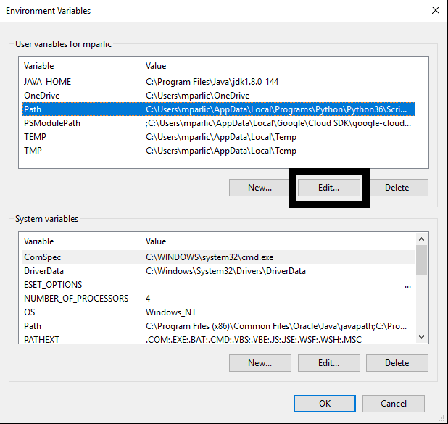
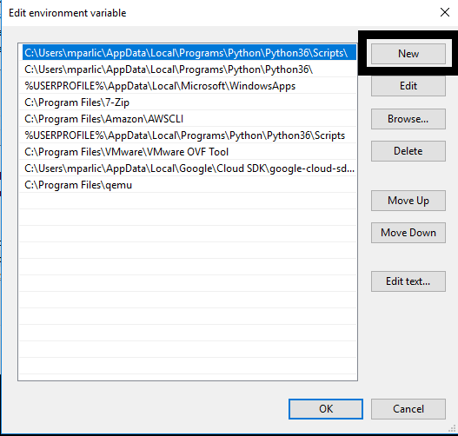
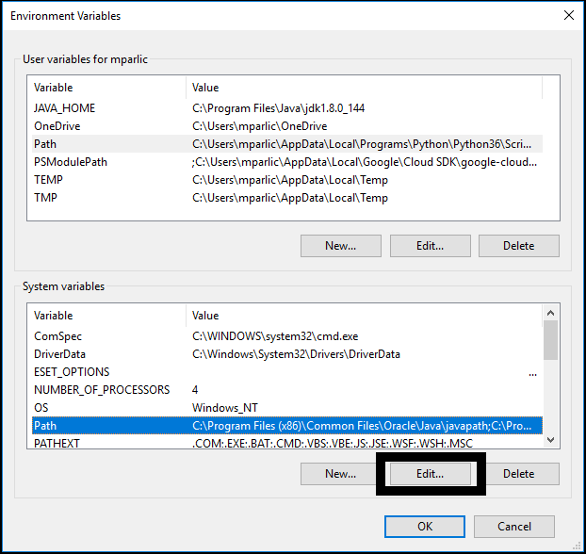
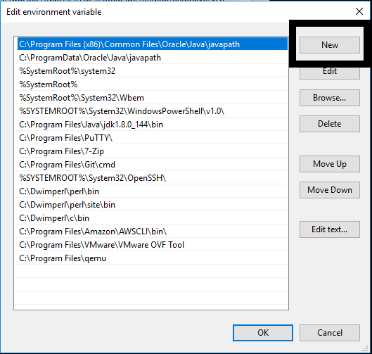

PREREQUISITE STEP 2 (Get VM Disk files of old HYCU Controller) video file
- Go to target where you have backup of HYCU controller
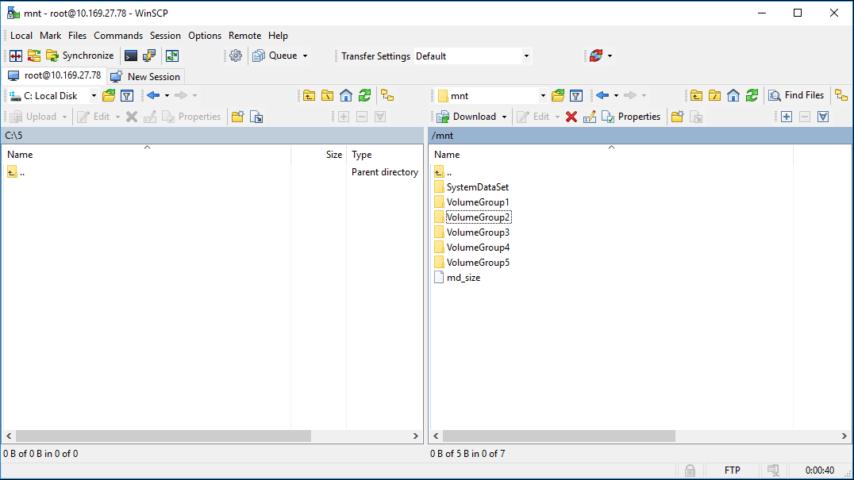
- Navigate to bkpctl directory
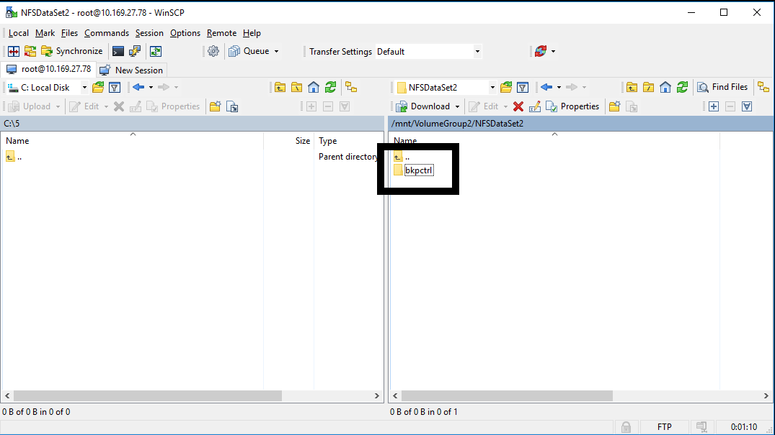
- Enter to directory that have name of UUID of previous HYCU controller
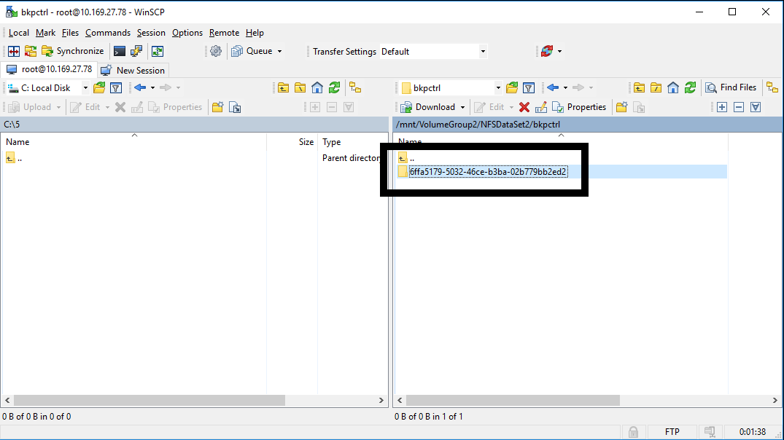

- Navigate to internal_backup_<source UUID>
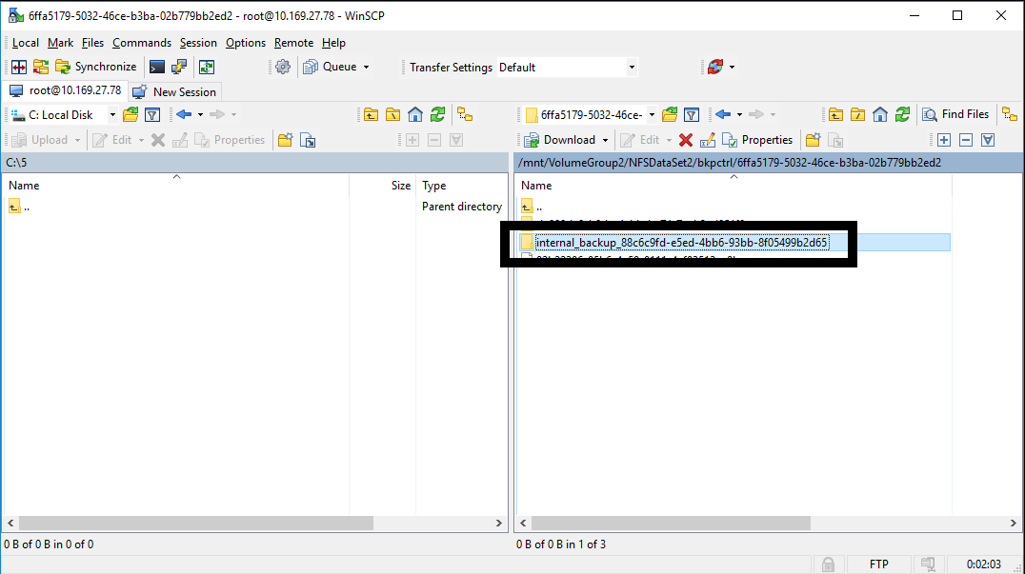
- Copy raw disk image files of HYCU controller to local computer (Virtual HDD files has crm files with same name, you only need files without extension
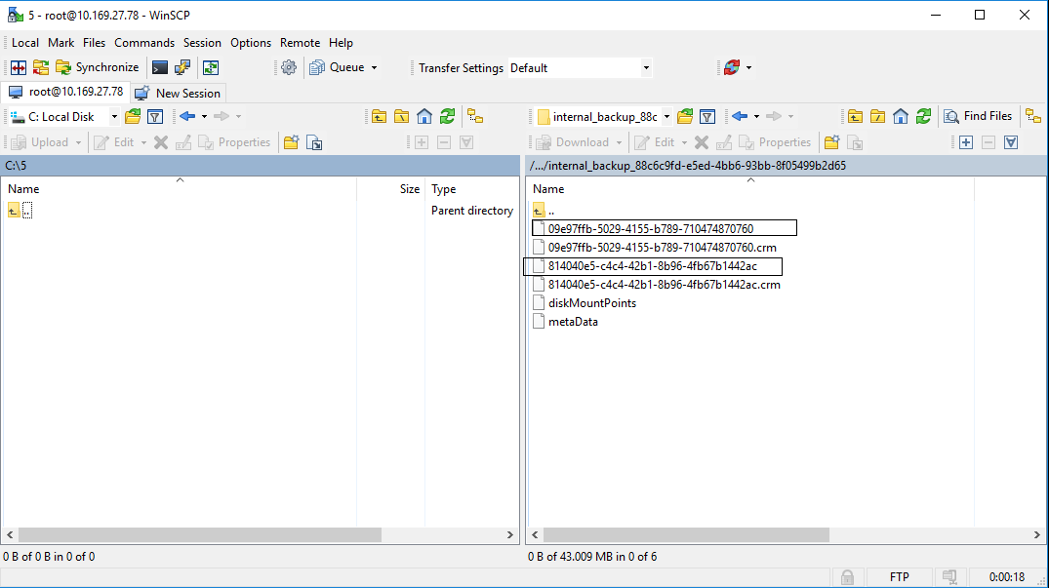
- Convert raw files to VMDK with QEMU tool (smaller file is boot disk, and should be first disk of VM)
command that need to be used is qemu-img –f raw –O vmdk <name of raw image file> <name of vmdk>.vmdk
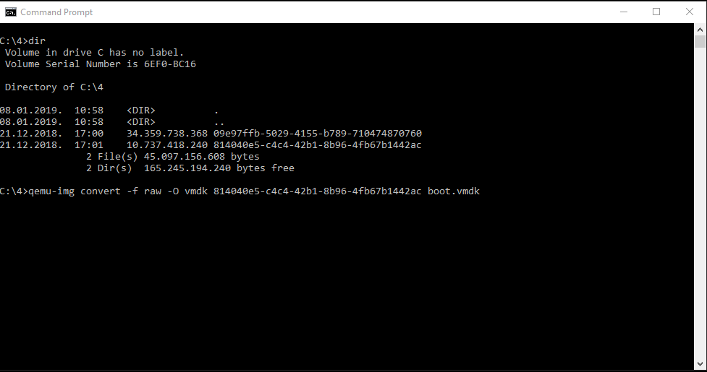
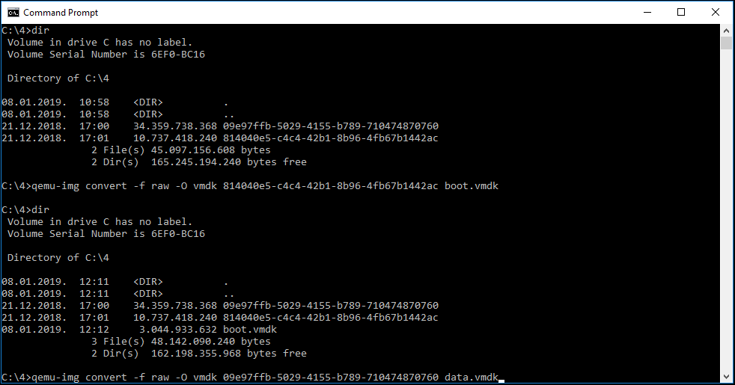
STEP 1 (Create new VM in VM Player and customize it) video file
- Select Create New Virtual Machine
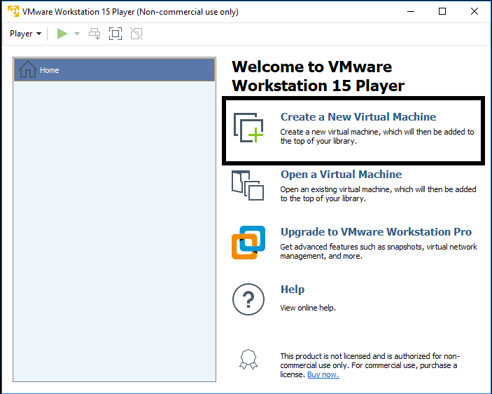
- On next screen select I will install operating system later
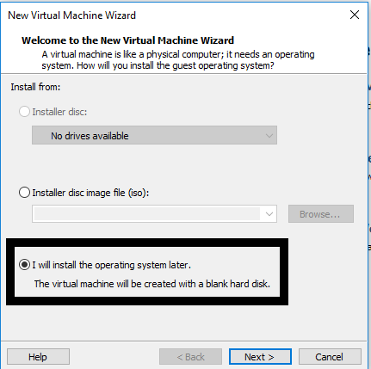

- On next screen select Linux on top and Version CentOS 7 64-bit
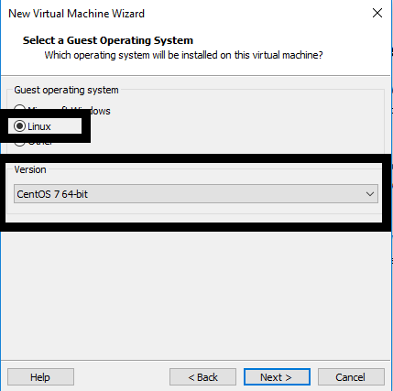
- Enter VM name and select location on local computer where VM will be stored
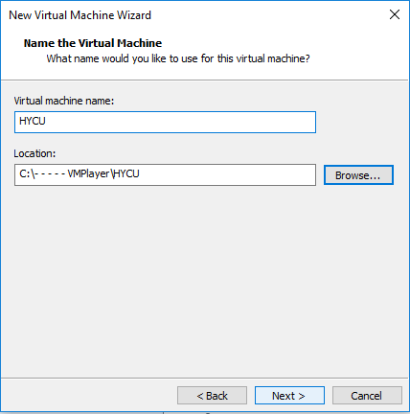

- Enter size of VM boot disk to be 10 GB and select Store Virtual disk as single file
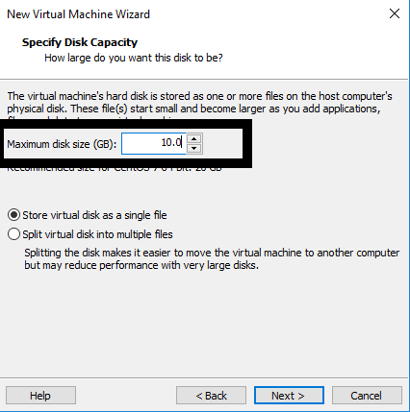
- On next screen click on finish
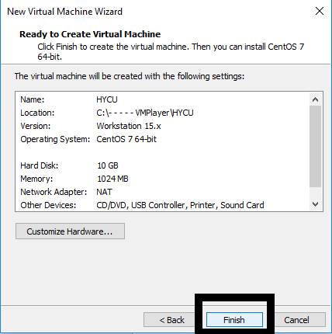

- Copy converted files to folder where your new VM is created
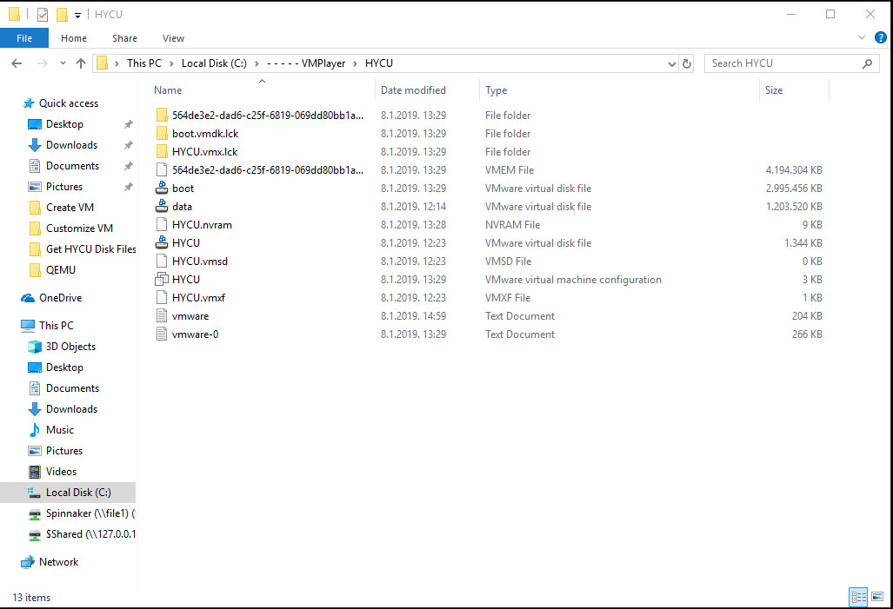
- Edit .vmx file with text editor .vmx file is located in folder where you created new VM (change line scsi0:0.fileName = "HYCU.vmdk" to scsi0:0.fileName = "boot.vmdk")
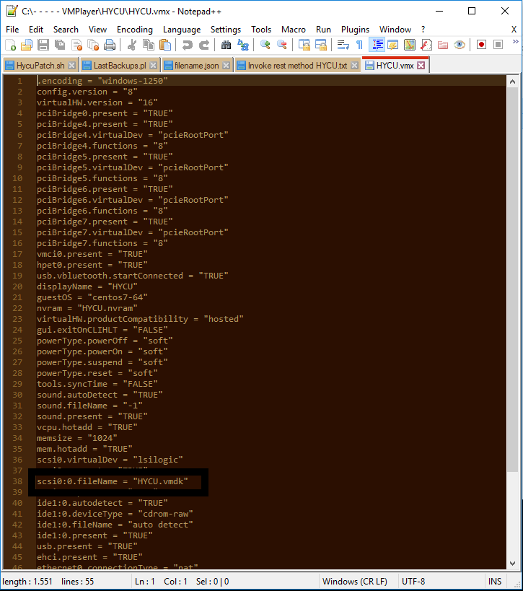

- Save File
- Open VM player, select VM and Select Edit virtual machine settings
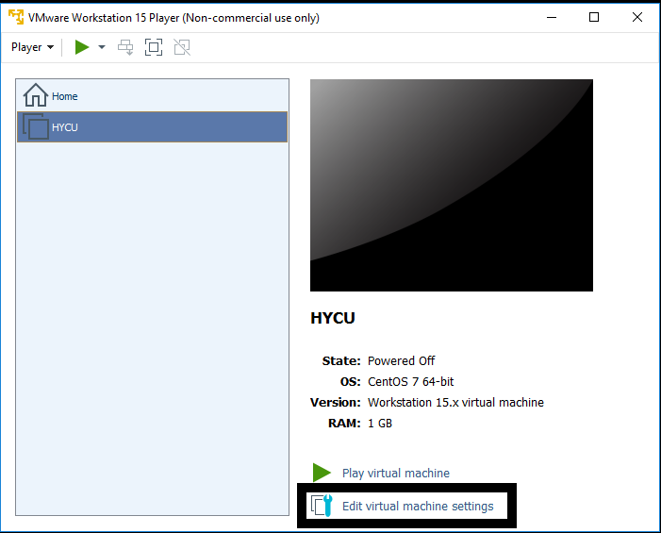
- Edit memory settings to 4 gb
- Edit Processors to 2 cores
- Remove CD drive
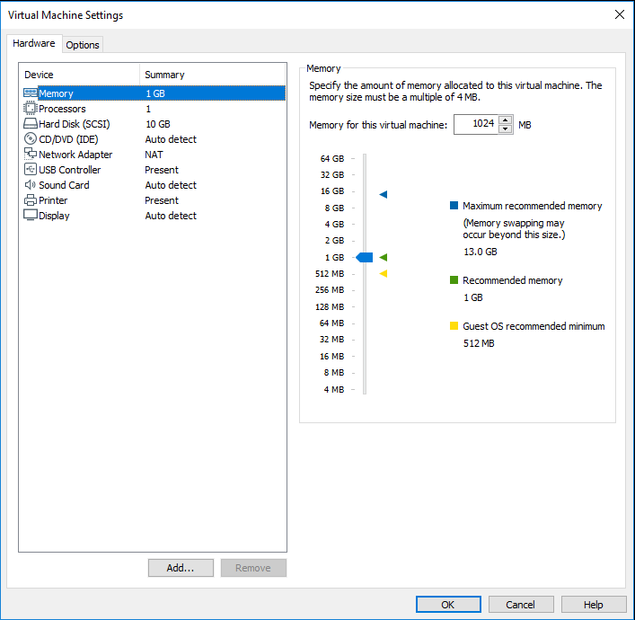

- Add another HDD, select SCSI hdd drive select use existing virtual disk, browse for data hdd file, click on finish and click on keep existing format
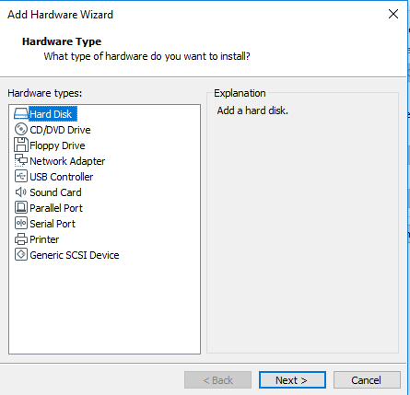
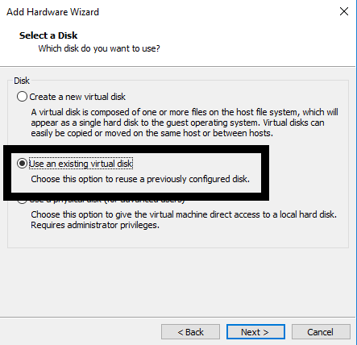
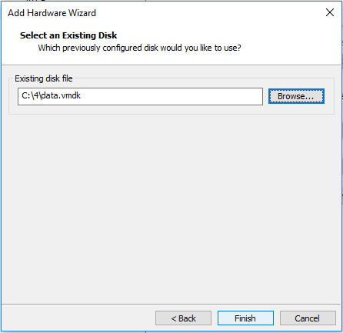
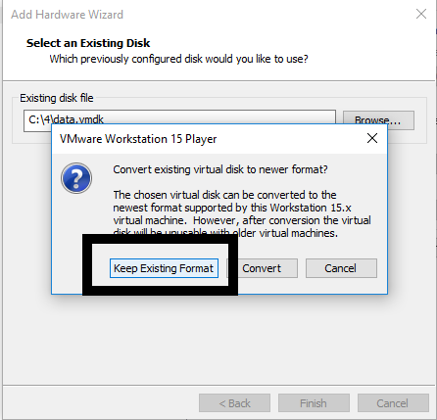
- On network controller select Nat
- Save VM settings
- Run VM
- When controller is up, login with credentials hycu / hucu/4u use command sudo nmtui to access network settings of controller, you will be asked to enter password one more time so enter hycu/4u
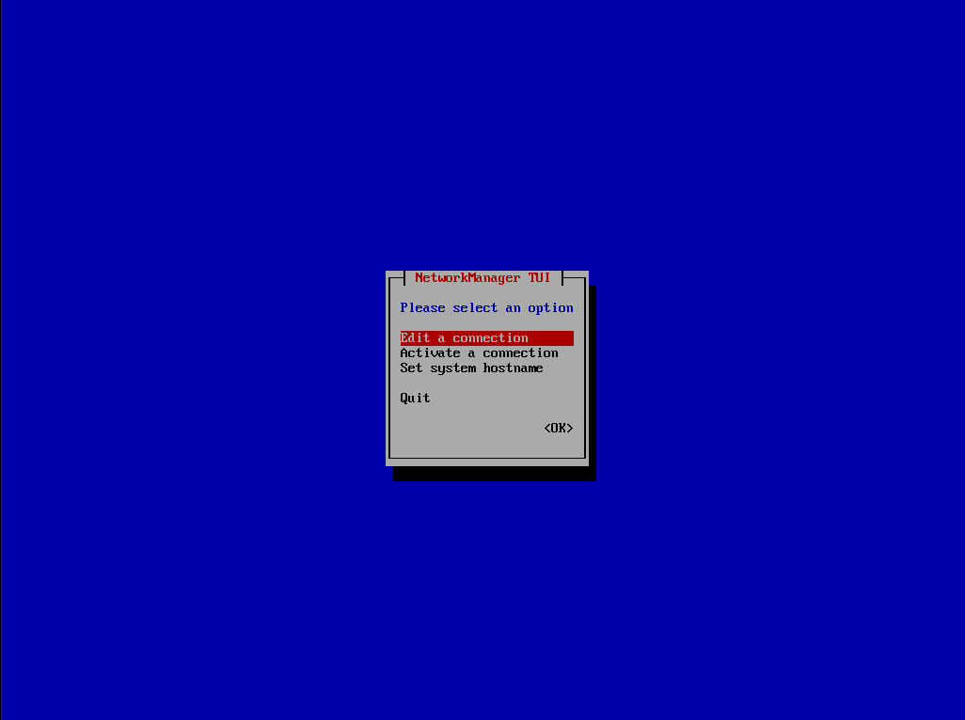
- Select Edit a connection
- Select Wired connection 1 and delete it
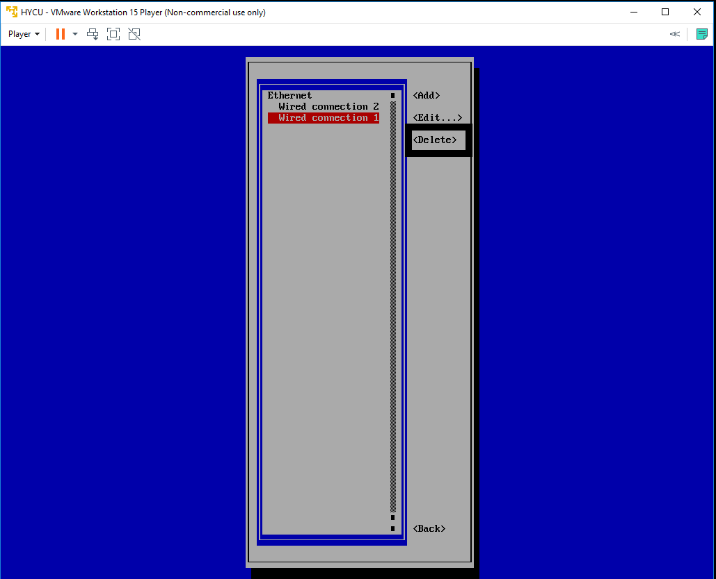

- Select Wired connection 2 and Edit it, change name to Wired connection 1
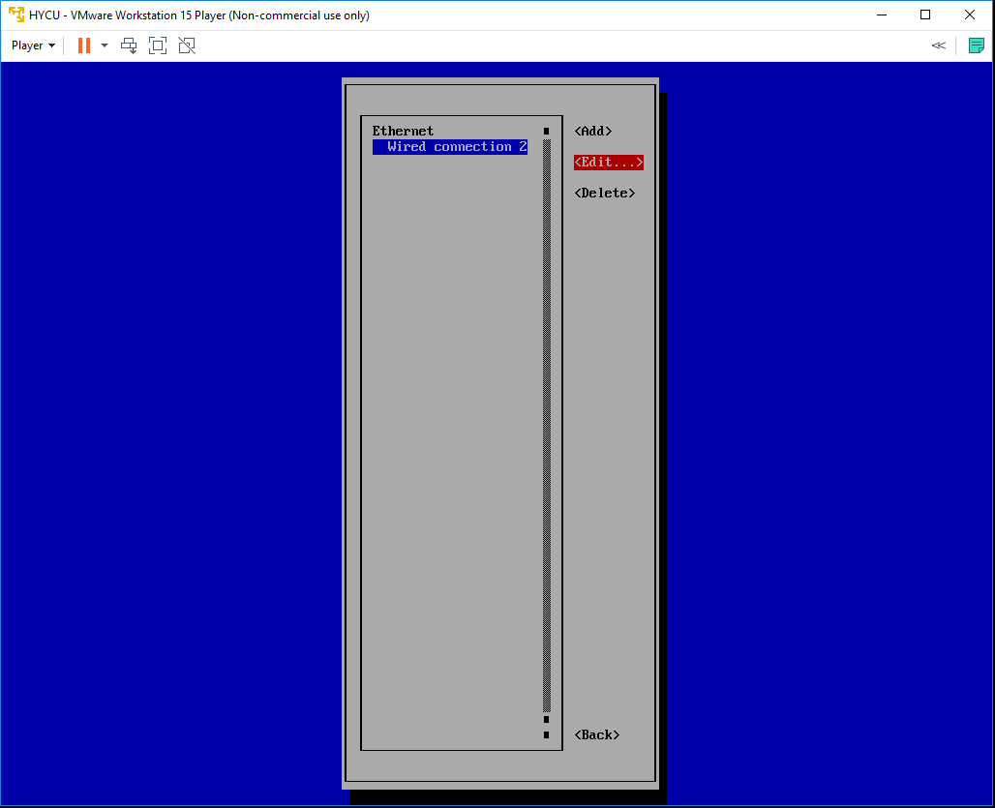
- Quit nmtui and reboot controller sudo shutdown –r now
- Login to console with same credentials and run ifconfig command to get controllers IP address
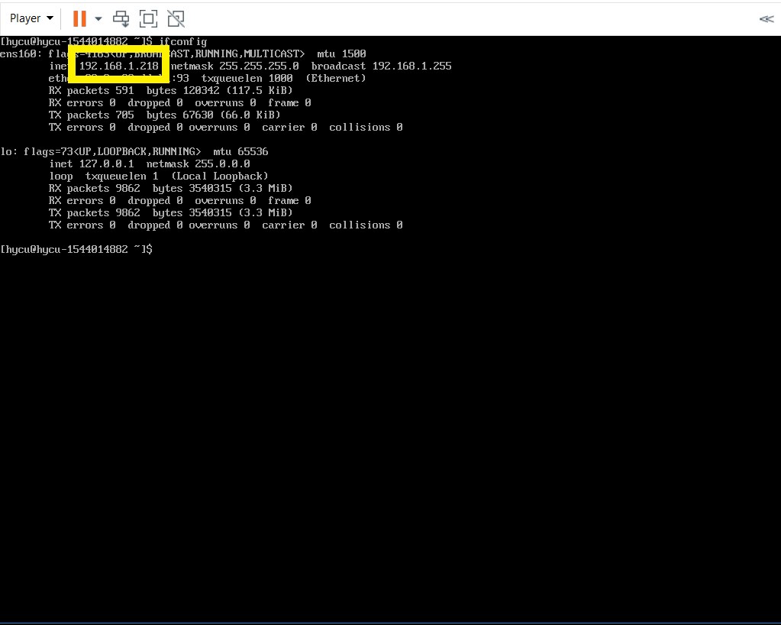
- Use that address to access HYCU GUI

STEP 2 (Restore VM Virtual Disk Files and convert them if needed) video file
- Navigate to Virtual Machines tab on left
- VMs that have backup will be shown as PROTECTED_DELETED since source is not available
- Select VM and select Restore VM or vDisks
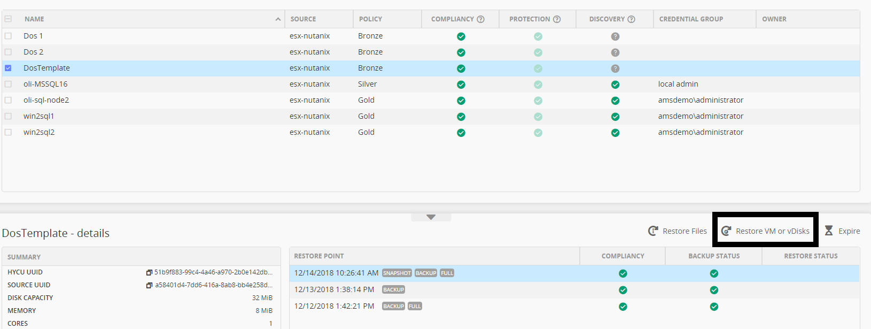

- New form will be shown. Disregard warning.
- Select Export vDisks
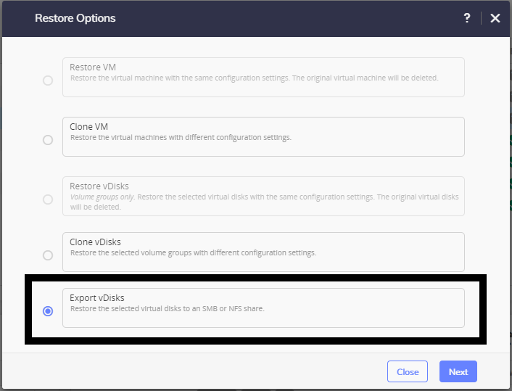
- Select vDisk that you want to export
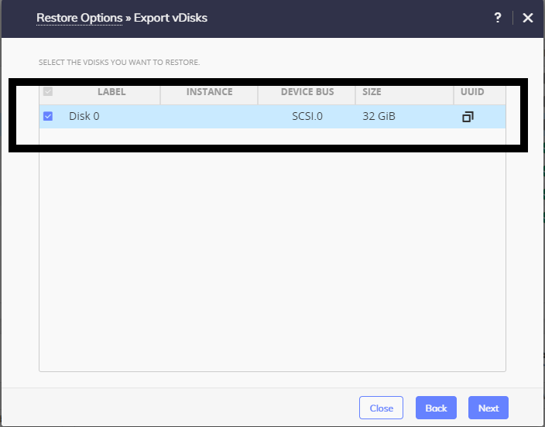
- Enter Share Data
For SMB
- Domain, Username and Password are optional if exists
- Enter SMB server DNS name or IP address
- Enter Shared Folder name in format /<FolderName>
- Choose Restore Instance (recommended is AUTOMATIC)
For NFS
- Enter NFS server DNS name or IP address
- Enter Shared Folder name in format /<FolderName>
- Choose Restore Instance (recommended is AUTOMATIC)
- Select Restore
- When restore job is completed, you should have something like this in shared folders. If you have multiply disk exported you will have multiply *.vmdk files in folder
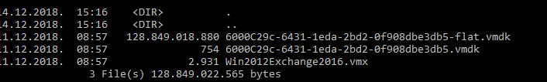
STEP 3 (Convert WMX fo;e tp PVA amd PVF) video file
- Convert *.vmx file to *.ova, for that operation you will need VMWare OVFTool available on https://my.vmware.com/web/vmware/details?productId=614&downloadGroup=OVFTOOL420
- Upon install add path of installation to environmental paths
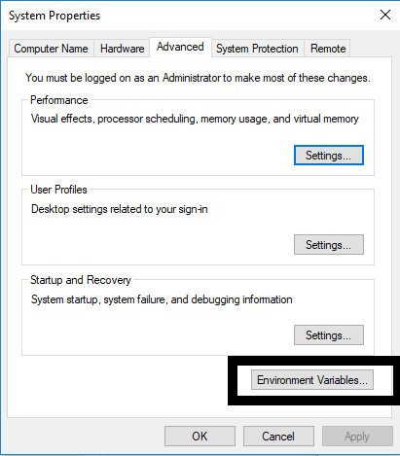
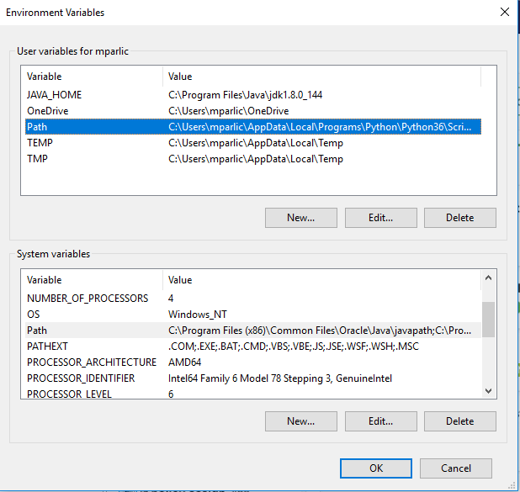
- Open Command prompt and navigate to share folder
- Use command ovftool nameOfFile.wmx nameOfFile.ova
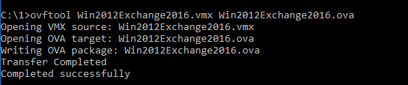

STEP 4 (Upload VM files to bucket) video file
- Upload all files to bucket on S3 using S3 Browser available on https://s3browser.com/?v=6-5-9&fam=x64
- Add your account
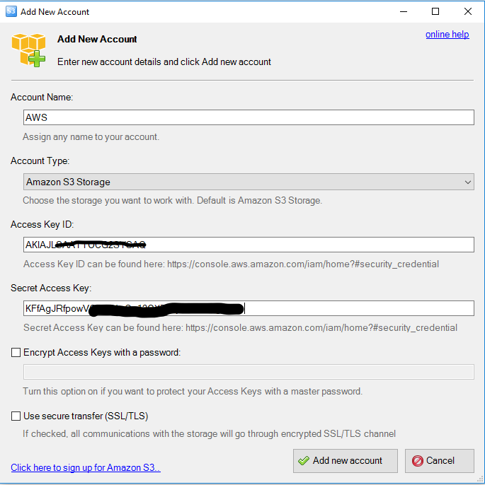
- Create New bucket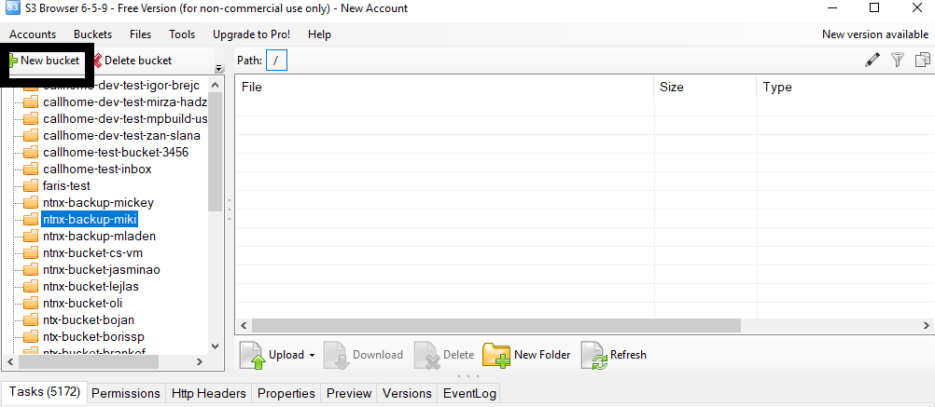
- Upload all *.ova files and *.vmdk files
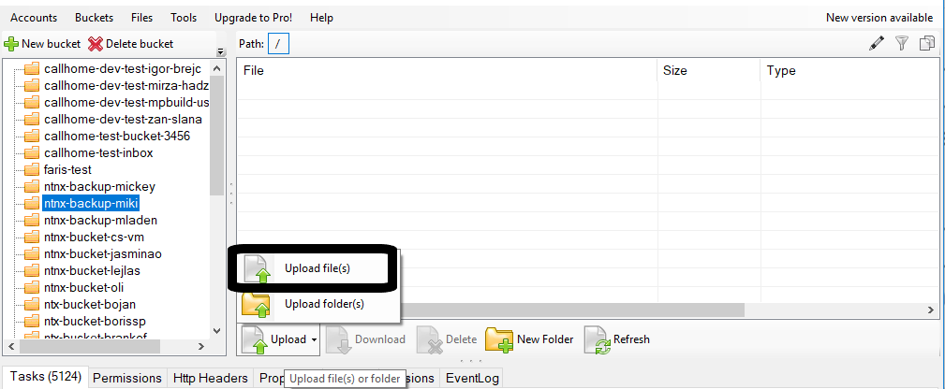
- Download AWS CLI from address https://aws.amazon.com/cli/ (download installer for Windows)
- Install AWS CLI
- Open Windows Powershell (run as administrator)
STEP 5 (AWS Configure) video file
- Enter command aws configure
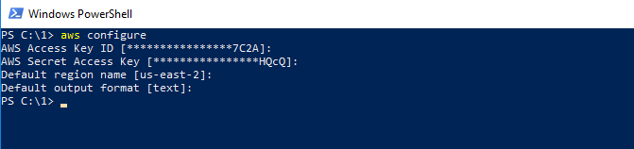
- Enter Access Key ID, AWS Secret Access Key, Default Region, and output type (text/json)

STEP 6 (Create and import vmimport policy) video file
- For next operation it is highly recommendable to have Admin permission on your AWS user, if not user need to have all permissions on EC2 and S3, and in the IAM part need to have iam:PutRolePolicy and iam:CreateRole.
- Create Folder on your local disk and navigate to the folder
- In that folder create trust-policy.json file, file should look like this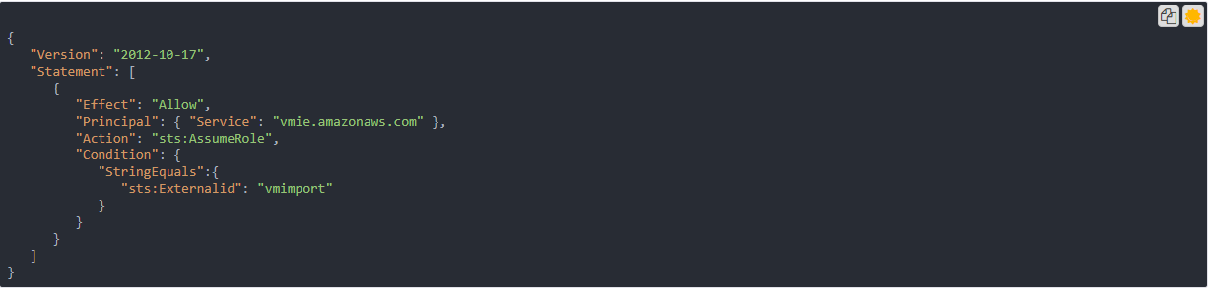
- Enter command aws iam create-role --role-name vmimport --assume-role-policy-document file://trust-policy.json
STEP 7 (Create and assign role policy) video file
- Create another file named role-policy.json where you need to replace disk-image-file-bucket with bucket name where you uploaded your disk images.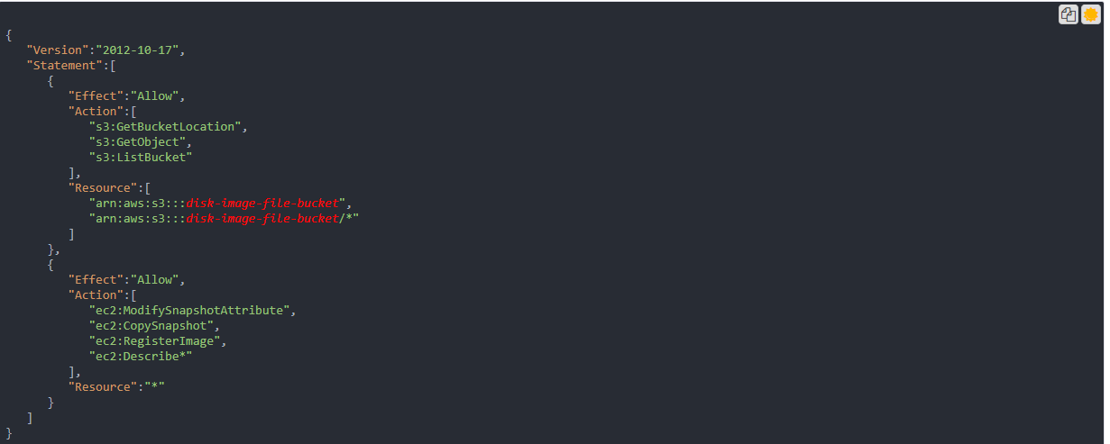

- Execute command aws iam put-role-policy --role-name vmimport --policy-name vmimport --policy-document file://role-policy.json

- Create containers.json file replace Description with your description, my-import-bucket with name of the bucket where you uploaded your files, na S3Key with name of your OVA File.
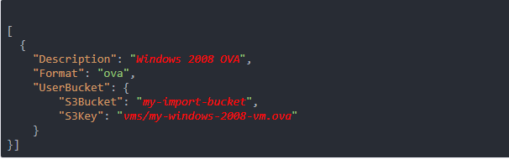

STEP 8 (Create containers.json and import VM) video file

- Execute command aws ec2 import-image --description "Windows 2008 OVA" --license-type <value> --disk-containers file://containers.json
- Import process will start
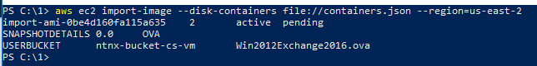
- You can check progress with command aws ec2 describe-import-image-tasks --import-task-ids import-ami-abcd1234 replace abcd1234 with number after import-ami-
- After successful import find VM in EC2 navigate to
https://us-east-2.console.aws.amazon.com/console/home?nc2=h_ct&region=us-east-2&src=header-signin#
- Select EC2
- Press button Launch Instance
- Select My Amis, and from that list run your VM that you imported

